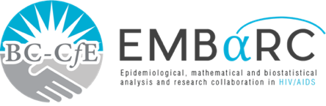

RESEARCH SUMMARY

# THE IMPACT OF TREATMENT AS PREVENTION ON THE HIV EPIDEMIC IN BRITISH COLUMBIA, CANADA



**St. Paul’s Hospital**

**608 - 1081 Burrard Street Vancouver, BC**

**FINDINGS**

* In BC, TasP has been associated with a steady decline in HIV-related illness and deaths.
* A demographic transition was observed among PLWH with the majority of those on HIV treatment now ≥ 50 years of age, living with at least one comorbidity, and dying from age-associated comorbidities.
* New HIV diagnoses have been rapidly declining, however, to a lesser extent among men who have sex with men in BC.
* Infectious syphilis cases in BC are increasing in this population.

**INTRODUCTION**

Treatment as Prevention (TasP) has been proven to be an effective strategy for controlling the HIV/AIDS epidemic. This strategy works by expanding HIV treatment and access among people living with HIV (PLWH). This study describes the impact of a publicly funded TasP strategy in decreasing the individual and public health impact of HIV/AIDS in British Columbia (BC), Canada.

**METHODS**

We utilized longitudinal data from the BC Centre for Excellence in HIV/AIDS’s Drug Treatment Program and the Seek and Treat for Optimal Prevention of HIV/AIDS population based cohort to capture socio-demographic, clinical, and treatment variables. Participants were followed until the last contact date with the provincial healthcare system (e.g., Drug Treatment Program entry, physician visits, hospitalizations, laboratory test), the date of death, study end, or the date in which they moved out of BC.

**PUBLIC HEALTH IMPLICATIONS**

* These findings reinforce the effectiveness of TasP in decreasing HIV spread, but at the same time, it highlights the need for further innovation to enhance the control of HIV and syphilis.
* This study supports the development of new approaches that address existing gaps in the TasP strategy in BC, and the future health needs of PLWH.

Authors: Viviane D. Lima, Zabrina L. Brumme, Chanson Brumme, Paul Sereda, Mel Krajden, Jason Wong, Silvia A. Guillemi, Bonnie Henry, Robert S. Hogg, Rolando Barrios, Julio S. G. Montaner

