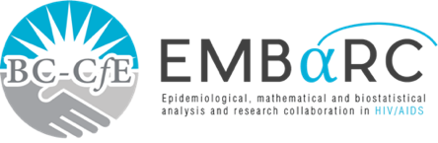

RESEARCH SUMMARY (Confrance Abs

ESTIMATION OF MEASUREMENT ERROR IN PLASMA HIV-1 RNA ASSAYS NEAR THEIR LIMIT OF QUANTIFICATION



**St. Paul’s Hospital**

**608 - 1081 Burrard Street Vancouver, BC**

**V5Z 1Y6 TEL: 604.806.8477**

**FINDINGS**

* All three tests had very similar accuracy.
* All three tests were less reliable when plasma viral load was less than 250 copies per millilitre.
* The closer the measurement was to the lowest detectable amount, the larger the measurement error in all three tests.

**INTRODUCTION**

It is important to measure the amount of HIV in plasma. The number of copies of virus per millilitre is called the ‘viral load’, and is used to make treatment decisions. This study compares the accuracy of different tests in measuring very low plasma viral load. Measurement errors can come from differences in the tested person’s body or can come from differences in the testing equipment. The accuracy of measurement is more important when the viral load is very low. When the viral load is very low, it is also more difficult to measure.

**PUBLIC HEALTH IMPLICATIONS**

Our findings demonstrate that when plasma viral load is very low, measurement error is more likely to cause false results. A single measurement should not be considered conclusive when viral load is under 250 copies per millilitre. A measurement of less than 250 copies per millilitre should be confirmed by a second test result with a similar low level.

**METHODS**

We compared plasma viral load measurements measured by three tests: COBAS HIV-1 Ampliprep AMPLICOR MONITOR ultrasensitive assay version 1.5, and COBAS Ampliprep Taqman HIV-1 assay versions 1.0 and 2.0. They analysed plasma viral load of new patients from British Columbia, Canada, during their first six months on treatment, when all tests were done with only one of each type of test. These tests measure can detect viral load down to 40 or 50 copies per millilitre.

**Authors:** Viviane D.Lima, Lu Wang, Chanson Brumme, Lang Wu, Julio S.G. Montaner, and P.Richard Harrigan

