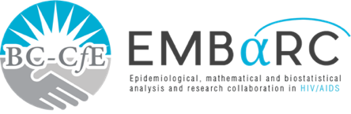

RESEARCH SUMMARY

# AN ASSESSMENT OF THE RELATIONSHIP BETWEEN THE WORLD HEALTH ORGANIZATION HIV DRUG RESISTANCE EARLY WARNING INDICATORS AND HIV DRUG RESISTANCE ACQUISITION



**FINDINGS**

* All explored early warning indicators were associated with at least one class of HIV drug resistance, with the exception of ‘ART prescribing practices’.
* Among all studied early warning indicators, virologic suppression at 12 months demonstrated the strongest association with HIV drug resistance.

**INTRODUCTION**

Antiretroviral therapy (ART) refers to a combination of HIV drugs that supress the HIV virus. The ability of HIV to mutate and reproduce itself in the presence of ART is called HIV drug resistance. The World Health Organization (WHO)’s HIV drug resistance early warning indicators measure ART-related factors associated with drug resistance prevention, without drug resistance laboratory testing. We assessed the relationship between early warning indicators and drug resistance attainment using data from British Columbia, Canada.

**CLINICAL IMPLICATIONS**

Several early warning indicators were associated with and predictive of HIV drug resistance. This supports the WHO early warning indicators as a component of the HIV drug resistance prevention method in settings where drug resistance testing is not routinely or widely available.

**METHODS**

We included individuals who had never used ART, were at least 19 years old, had initiated ART between 1 January 2000 and 31 December 2012, had at least 15 months of follow-up, and were without transmitted drug resistance.

**Authors:** Martin St-Jean, Richard Harrigan, Paul Sereda, Julio SG Montaner and Viviane D Lima

, Ignacio Rozada

b

, Jummy David

a,c

, David M. Moore

a,d

, Silvia A. Guillemi

a

, Rolando Barrios

a

,

Julio S.G. Montaner

a,e

, Viviane D. Lima



**St. Paul’s Hospital**

**608 - 1081 Burrard Street Vancouver, BC**