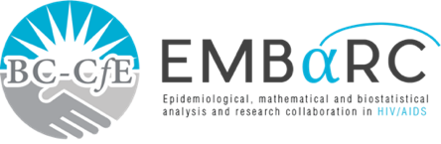

RESEARCH SUMMARY (Confrance Abs

CONDITIONS FOR ERADICATING HEPATITIS C IN PEOPLE WHO INJECT DRUGS: A FIBROSIS AWARE MODEL OF HEPATITIS C VIRUS TRANSMISSION



**St. Paul’s Hospital**

**608 - 1081 Burrard Street Vancouver, BC**

**V5Z 1Y6 TEL: 604.806.8477**

**INTRODUCTION**

Hepatitis C is a major global health concern as it is the most common blood-borne disease. It is estimated that 80% of new hepatitis C infections occur among people who have ever injected drugs (PWID). However, PWID have made up only a small minority of people treated for hepatitis C. A new and highly effective hepatitis C treatment has been available since 2012. This study predicts uses mathematical modelling to predict the infection, treatment, and re-infection of hepatitis C among PWID while considering the impact of liver damage. This study also explored the impact of harm reduction on reducing re-infection.

**FINDINGS**

* Preventing almost all new infection with hepatitis C in BC is possible with increased testing, treatment, and harm reduction.
* The most effective way to reduce new infections is to reduce the number of contacts with hepatitis C. This supports the effectiveness of harm reduction.
* Reducing the time a person has acute hepatitis C infection will also reduce transmission.

**PUBLIC HEALTH IMPLICATIONS**

Hepatitis C prevention among PWID should be a priority in BC. There are three strategies that may eventually reduce new infections to zero:

1. Implementing harm reduction to reduce blood-to-blood contact. Providing new needles and syringes for injecting drug users is particularly important.
2. Increased testing to diagnose people earlier.
3. Decreasing the time to access treatment.

**METHODS**

The model was developed using data from the PWID population of British Columbia (BC), Canada. Parameter estimates were drawn from published data.

**Authors:** Ignacio Rozada,, Daniel Coombs, and Viviane D. Lima

